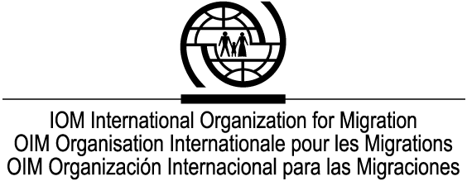

Annex B

Consultants Information Form

This form can be filled in electronically.

Enter text in the spaces provided below. If you are completing this form electronically, type in the grey boxes, check the checkbox where applicable, and select an appropriate item from a drop-down menu.The boxes will expand as you type. Note that the "IOM Comments" box under section 8 should be completed by the IOM project manager.

1. Name
Title | Surname | First Name | Middle Name | Maiden Name (if any)

2. Affiliation
Job Title

Department

Organization

3. Contact information
Enter one address where you can be contacted.
Address

(City/Region)

(Postal code)

(Country)
Phone
Fax
Email
URL

4. Nationalities

5. Language

Enter up to 6 languages you are proficient in, and rate your communication skills and writing ability for each. If you are completing this on screen, select the appropriate item from the drop-down menu provided. If you are completing this on paper, enter either “excellent”, “good” or “fair”.

Language | Communication Skills | Writing Ability

6. Academic background

7. Usual profession

8. Expert’s specialities

Check the items where you feel have an expertise. Select all that apply.

Activity
Inter-Agency Workshops  Expert working groups  Advisory services  Exchanges/visits of experts  Inter-state working groups on migration  Educational courses in migration  Forum activities  Facilitation of Govt./NGO dialogue | Training  System analysis/management  Research/Analysis  Surveys  Statistical data gathering  Evaluation  Direct medical care  Programme development

Area of expertise
Migration policy  Migration legislation  Migration administration  Migration procedures  Information systems and management  International relations  Psychiatry/mental health  Reproductive health  Public health  Aviation medicine  Emergency medicine | Biostatistics  Emerging diseases  Environmental health  Radiology  Laboratory sciences  Infectious diseases  Language training  Cultural orientation  Teacher training/curriculum development  Building intercultural awareness  Migrant workers’ rights and obligations  Migration terminology

Migration focus
Immigration  Emigration  Transit migration  Labour migration  Internal displacements  Return and reintegration  Asylum/refugees  Emergency assistance  Camp management  Border management  Migrant trafficking  Migrant women in vulnerable situations  Citizenship  Post-conflict demobilization  Free movement of people | Return/transfer of skills  Migrant health Project management  Illegal migration  Census  Regularization of illegal migrants  Migrants’ rights  Regional/international migration legislation  Ecological migration  Formerly deported peoples  Labour insertion of migrants  Overall migration management process  Displaced persons  Legal status and rights of foreigners  Migrant health  Travel medicine

Region
Western and Northern Europe  Central and Eastern Europe  CIS  Mediterranean Basin  Northern Africa  Western Africa  Eastern Africa  Great Lakes region  Central Africa  SADC countries  Middle East | Central Asia  South East Asia  Southern Asia  Eastern Asia  Oceania  North America  Central America and Mexico  Caribbean countries  Andean countries  Mercosur countries

9. Consultancy history with IOM

Please indicate name of project, dates, geographic location, and name of the project manager. The project manager should state in the "IOM Comments" box whether and to what extent the TORs have been fulfilled by the expert upon completion of the contract.

Name of project | Dates (e.g. Jan-96) | Geographical location | IOM project manager | IOM Comments  (Leave blank)
 | to
 | to
 | to

10. Other consultancy history (e.g. for the last 3 years)

Contracting Agency | Subject | Dates | Consultancy  Fee
 |  | to
 |  | to
 |  | to

11. Other relevant experience/employment in the migration field

12. Availability for consultancy (e.g. immediate, one month’s notice etc.) and usual fee

Availability | Usual fee

13. IOM contact (also for copy of your curriculum vitae)

14.

Yes, I would like to be included in the Migration Network

